**Circuit-Switching and Packet-Switching Networks**

Networks are devices that are connected together using special hardware and software that allows them to exchange information. There are many methods for exchanging information between networked devices. There are also a number of ways of categorizing and describing these methods and the types of networks that use them.

One fundamental way to differentiate between networking technologies is on the basis of the method used to determine the path between devices over which information will flow. In highly simplified terms, there are two approaches: a path can be set up between the devices in advance, or the data can be sent as individual data elements over a variable path.

**Circuit Switching**

In the circuit-switching networking method, a connection called a circuit, which is used for the whole communication, is set up between two devices. Information about the nature of the circuit is maintained by the network. The circuit may be either a fixed one that is always present or one that is created on an as-needed basis. Even if many potential paths through intermediate devices may exist between the two devices that are communicating, only one will be used for any given dialogue, as shown in Figure 1. The classic example of a circuit-switched network is the telephone system. When you call someone and she answers, you establish a circuit connection and can pass data in a steady stream. That circuit functions the same way, regardless of how many intermediate devices are used to carry your voice. You use it for as long as you need it and then terminate the circuit. The next time you call, you get a new circuit, which may (probably will) use different hardware than the first circuit did, depending on what’s available at that time in the network.

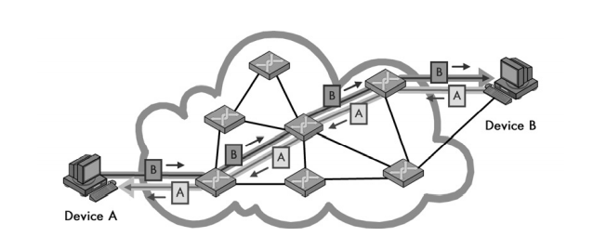

Figure 1: Circuit switching- In a circuit-switched network, before communication can occur between two devices, a circuit is established between them. This is shown as a darker line for the conduit of data from Device A to Device B, and a matching lighter line from B back to A. Once it’s set up, all communication between these devices takes place over this circuit, even though there are other possible ways that data could conceivably be passed over the network of devices between them.

**Packet Switching**

In the packet-switching networks, no specific path is used for data transfer. Instead, the data is chopped up into small pieces called packets and sent over the network. You can route, combine, or fragment the packets as required to get them to their eventual destination. On the receiving end, the process is reversed—the data is read from the packets and reassembled to form the original data, see Figure 2.

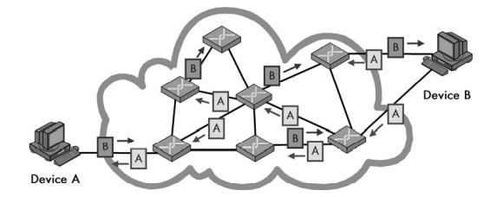

Figure 2: Packet switching- In a packet-switched network, no circuit is set up prior to sending data between devices. Blocks of data, even from the same file or communication, may take any number of paths as they journey from one device to another.

*KEY CONCEPT One way that networking technologies are categorized is based on the path used to carry data between devices. In circuit switching, a circuit is first established and then used to carry all data between devices. In packet switching, no fixed path is created between devices that communicate; it is broken into packets, each of which may take a separate path from sender to recipient*

**Which Switching Method to Choose?**

A common temptation when considering alternatives such as these is to ask which is better; the answer is neither. There are places for which one is more suited than the other, but if one were clearly superior, both methods wouldn’t be used.

One important issue in selecting a switching method is whether the network medium is shared or dedicated. Your phone line can be used for establishing a circuit because you are the only one who can use it. However, this doesn’t work well with LANs, which typically use a single shared medium and baseband signaling. If two devices were to establish a connection, they would lock out all the other devices for a long period of time. It makes more sense to chop the data into small pieces and send them one at a time. Then, if two other devices want to communicate, their packets can be interspersed, and everyone can share the network.

The ability to have many devices communicate simultaneously without dedicated data paths is one reason why packet switching is becoming predominant today. However, there are some disadvantages of packet switching compared to circuit switching. One is that since all data does not take the same predictable path between devices, it is possible that some pieces of data may get lost in transit or show up in the incorrect order. In some situations, this does not matter, but in others it is very important indeed.

Although the theoretical difference between circuit and packet switching is pretty clear-cut, understanding how to use them is a bit more complicated. One of the major issues is that in modern networks, they are often combined.

Another issue is the relationship between circuit and packet switching, and whether a technology is connection-oriented or connectionless. The two concepts are related but not the same, as you will see in a moment

NOTE The word packet is only one of several terms that are used to refer to messages that are sent over a network. Other terms that you will encounter include frame, datagram, cell, and segment.

**Message Addressing and Transmission Methods: Unicast, Broadcast, and Multicast**

In a networking technology that uses messages to send data, you must undertake a number of tasks in order to successfully transmit the data from one place to another. One is simply addressing the message—putting an address on it so that the system knows where it is supposed to go. Another is transmitting the message, which is sending it to its intended recipient.

There are several different ways of addressing and transmitting a message over a network. One way in which messages are differentiated is in how they are addressed and how many recipients will receive them. The method used depends on the function of the message and also on whether or not the sender knows specifically or generally whom they are trying to contact.

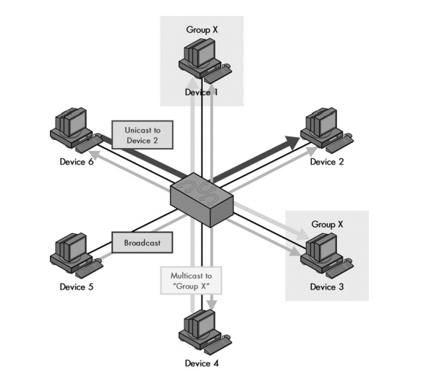

Figure 3: Unicast, multicast, and broadcast message addressing and transmission The three basic types of addressing and message delivery in networking are illustrated in this simplified LAN. Device 6 is sending a unicast message to Device 2, shown as the dark, heavy arrow. Device 4 is sending a multicast message to multicast group X, shown as the medium-weight arrows. In this case, that group includes Devices 1 and 3, which are highlighted. Finally, Device 5 is sending a broadcast message, which goes to all other devices on the LAN, shown as the thin, faint arrows

**Unicast Messages** These are messages that are sent from one device to another device; they are not intended for others. Of course, there is still the possibility of overhearing or even eavesdropping on it. Addressing a message to a particular computer doesn’t guarantee that others won’t also read it; it’s just that they normally will not do so.

**Broadcast Messages** as the name suggests, these messages are sent to every device on a network. You use them when you need to communicate a piece of information to everyone on the network, or when the sending station needs to send it to just one recipient, but doesn’t know its address. In networks, broadcast messages are used for a variety of purposes, including finding the locations of particular stations or the devices that manage different services.

**Multicast Messages** These are a compromise between the previous two types. Multicast messages are sent to a group of stations that meet a particular set of criteria. These stations are usually related to each other in some way. For example, they serve a common function or are set up into a particular multicast group. (Note that you can also consider broadcast messages to be a special case of multicast in which the group is “everyone.”)

Since these transmission methods differ based on how many and which devices receive the transmission, they are tied directly to the methods used for addressing, as follows:

**Unicast Addressing** Unicast delivery requires that a message should be addressed to a specific recipient. This is the most common type of messaging, so this addressing capability is present in almost all protocols.

**Broadcast Addressing** Broadcasts are normally implemented via a special address that is reserved for that function. Whenever devices see a message sent to that address, they all interpret it as “This message goes to everyone.”

**Multicast Addressing** Multicasts are the most complex type of message because they require a means of identifying a set of specific devices that will receive a message. It is often necessary to create several such groups, which may or may not partially overlap in their membership. Some mechanism is needed to manage which devices are in which groups.

*KEY CONCEPT Three basic methods are used to address and transmit data between networked devices. A unicast transmission goes from one device to exactly one other; this is the most common method used for most message transactions. A broadcast transmission is sent from one device to all connected devices on a network. A multicast transmission is addressed and sent to a select group of devices*

**Point –to-Point** in P2P networks or links, only two devices are connected together, forming what is often called a point-to-point network. In this situation, everything sent by one device is implicitly intended for the other, and vice versa. Thus, no addressing of messages on a point-to-point link is strictly necessary.

NOTE A new type of message-addressing method was defined as part of IP version 6 (IPv6): the anycast message. This term identifies a message that should be sent to the closest member of a group of devices.